Date: 26 March 2014

To:
Worldsustainabilityfund
Emile van Essen

Subject: Business document

Dear Emile,

Referring to our discussion about a loan agreement, I would like to send you the last update of this pitch document.

History  Our company’s sales executive Mr M. van Klaveren, being active in the water treatment business, made acquaintance with a high level contact in the Kazakh government. This contact opened doors to the highest level. Mr Van Klaveren got the opportunity to give presentations, to attended business meetings and was introduced to very important people, including the vice-president. In this period, the business relationship extended to a more personal level, which is very important in Kazakhstan. As a result of this, various business opportunities were offered. | 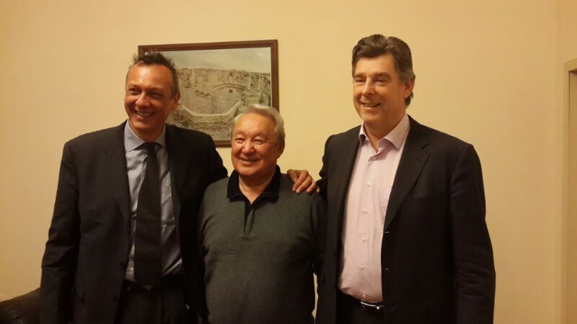  Marcel van Klaveren and the 2nd man of Kazakhstan,  Mr Naribayev Maksut Sultanovich | 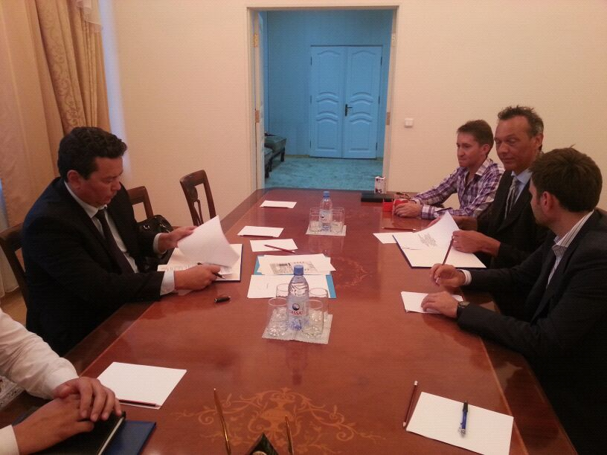  Marcel van Klaveren signing the contract.
Business
We have yet taken the chance to accept two business offers:
- The first one is a project for the supply of equipment for sewage treatment plants for all the major cities in Kazakhstan within the “Ak-Bulak” investment program.
- The other project is the delivery of prefab concrete elements for the “affordable housing” program.

The “Ak-Bulak” program (www.primeminister.kz/program/about/index/10) is initiated by the Kazakh government in order to upgrade the existing water treatment and water supply infrastructure. Our company will act as one of the main supplier of equipment for 46 waste water treatment facilities in major cities of Kazakhstan, 8 facilities have been officially awarded to us already. The total contract value is estimated at $ 400 million. A part of the equipment shall be fabricated at our new factory zone of Karaganda, Kazakhstan. The foundation of the factory is yet to be laid. The requested capital for the funding of the production facilities in Kazakhstan is about $25 million.

The “Affordable housing 2020” program was launched by the Kazakh government in order to improve the country’s public housing conditions. We have a contract for the guaranteed delivery of 100.000 m2 of prefab concrete apartments per annum in Ust-Kamenogorsk region in the period from 2014 to 2020. We are currently in the process of finalizing the order for this project with our partner Stylotec, Washington, USA.

We have founded a holding company in Kazakhstan for the development of the business, DKDC (Dutch Kazakhstan Development Company).
The total requested capital for the funding of the production facilities in Kazakhstan is $25 million.
We plan to repay the loan within a period of 5 years.

I hope you are interested in our company and we can realize a cooperation as soon as possible,

Sincerely yours,
Kemeo BV

